CSUEB NIU KQi 100P Electric Scooter Rollout
INDE 460
05/05/26
Team Members: Harman Singh, Camari Randolph, Evan Warren, and Andrew Ibrahim

1. Part II: Conceptual System Design (Type A Specification)
II-A. Problem Definition: California State University East Bay seeks to provide its students with an enjoyable and convenient education experience. Most of the student population commute long distances to campus and are constrained by time and additional responsibilities. Student parking is limited and located in the outskirts of the campus at various elevations.
Therefore, this project proposes the localized rollout of electric scooters to support students’ time constraints as they travel across campus. By providing quick, on‑demand mobility between parking areas, classrooms, and other facilities, the scooter system aims to reduce transit time, alleviate fatigue, and improve overall campus accessibility.
B1. Key Stakeholders
  - Cal State East Bay (Administration) - Financial capital, maintenance/support technicians’ employment, liability, infostructure impact.
  - Students - The primary end-users, fast, reliable and enjoyable transportation.
  - Faculty - Secondary users, also impacted by student punctuality and pathway congestion.
  - Campus and Hayward Police Departments - Enforcing safety, accident response, and theft prevention.
  - Surrounding Local Community - May be affected by scooter parking, noise, or sidewalk usage near campus borders.
C. Governing Documents & Regulations:
  - CSU East Bay campus policies - Pedestrian right‑of‑way, scooter parking restrictions, speed limits on walkways.
  - California Vehicle Code (CVC) - Electric scooters must have lights, brakes, no sidewalk riding, max 15 mph.
  - ADA accessibility - Scooters must not block wheelchair paths; station placement must comply with ADA clearances.
  - Local Hayward ordinances - Sidewalk obstruction, parking, operation on city streets bordering campus.
  - Required permits include CSU Building, ADA, Electrical, Fire Marshal, EHS, and annual SMOP.
D. System Specification (The "What"):
  - D1: Users - Campus students/staff, parking to classroom travel,
  - D2 : Operation Timeframe - August 2026 through August 2031
  - D3: Maintenance/Support - Outsource hourly technicians through a partnership with a local company such as East Bay Motorsports.
  - D4: Feasibility
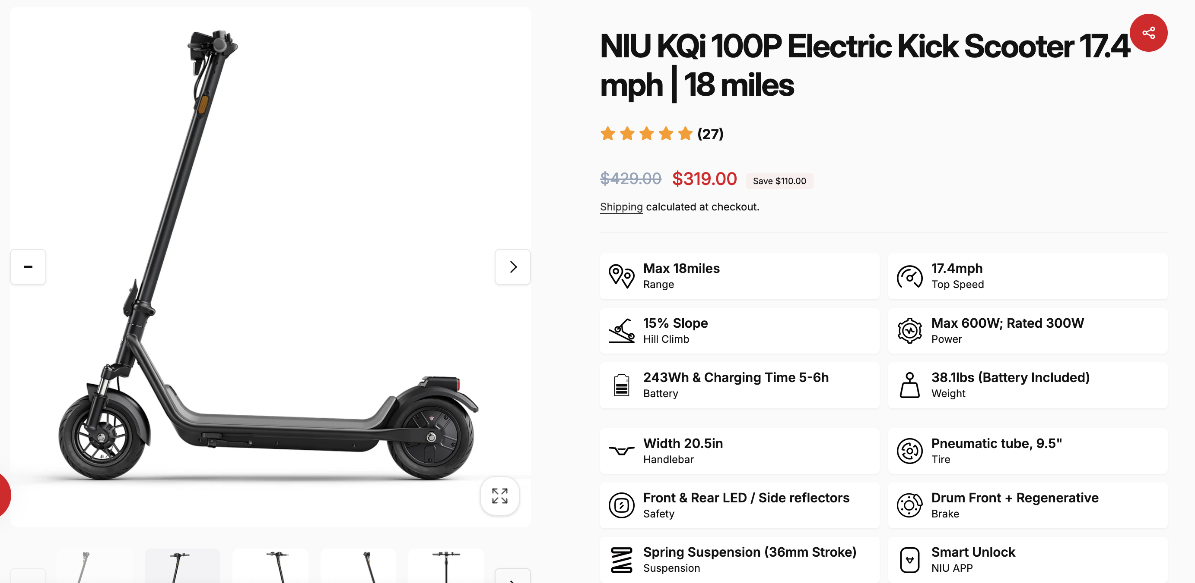
Figure 1: Project Vehicle NIU KQi 100P

    - Hills and Terrain:
NIU KQi 100P handles moderate slopes. Geofencing (Joyride) will be used to manage speed and restrict high‑risk downhill zones.
    - Injury Risk:
Geofencing (Joyride) will be used disable scooters outside of set Campus boundaries and in high risk-zones.
    - Charging:
Five Kuhmute smart hubs will be site developed with 20 ports each allow overnight charging of the full active fleet. Along with standard charging in storage for 30 scooter rotation fleet.
    - Maintenance:
Outsourced technician at $100/hr. partnership with local service such as East Bay Motorsports, with 2‑month spare parts stock and managed service log.
    - Storage of Spare Fleet & Parts:
A designated on‑site storage unit ($3,000 capital cost) houses up to 50 spare scooters and component inventory, ensuring quick replacement without off‑site delays.
    - Annual Revenue Scenarios Before
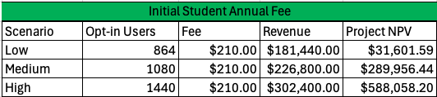
Figure 2 Annual Opt-in fee revenue Scenarios
With a $210.00 Annual fee (annually inflated) for Opt-in student’s the project NPV 32k to 588k.
However, should User opt-in numbers drop below the estimated 1080 annual figure, a tier structure will trigger to support revenue gains.

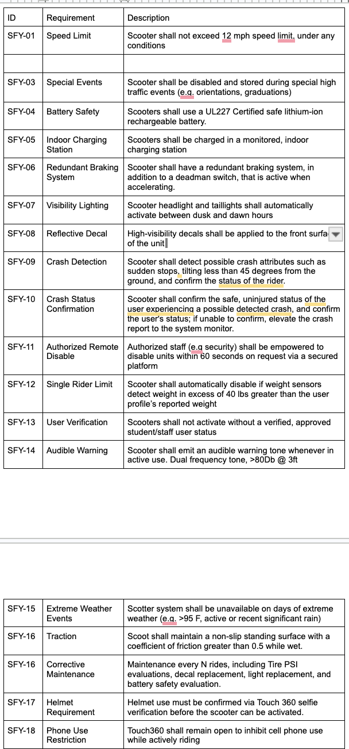
Figure 3: User code and Guidelines

  - D5: System-level TPMs (Success metrics like "Rides per day").

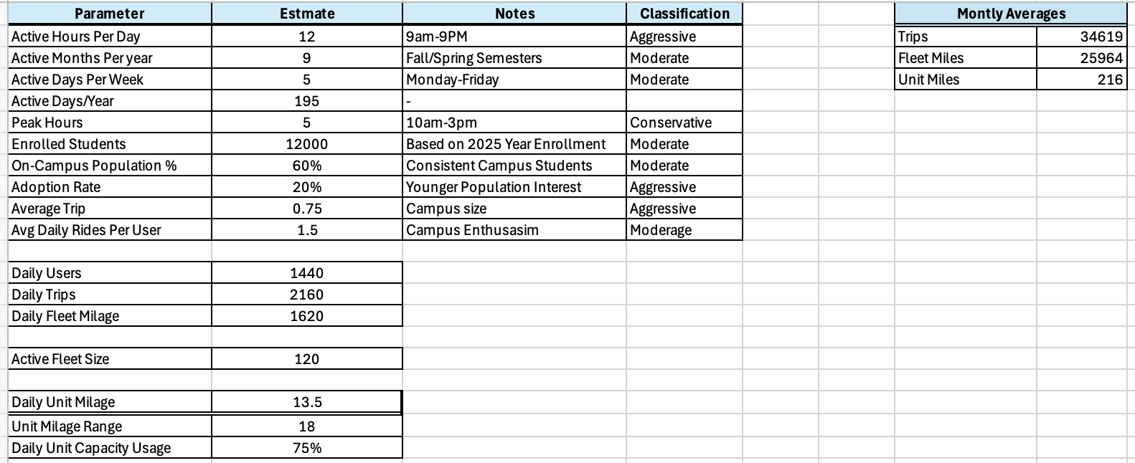
Figure 4: Program Usage Estimates
  - D6: Requirement Allocation (Which requirements go to the App vs. the Bike?).
User login and account access are managed through Joyride in combination with CSU credential verification. Speed control is handled by the Joyride IoT module using location-based infrastructure. Braking and lights are controlled directly by the scooter and the user. No crash detection system is included. Geofencing is implemented through the Joyride scale plan. Charging and fleet management are handled by Kuhmute smart hub stations, with users prompted to end rides and return scooters to a charging station when battery level falls below 30%.

Part III: Development Specification (Type B)
- Note: This is usually a table or list format.
- Subsystem 1: Vehicle Subsystem (NIU KQi 100P)
  - Top speed: 17.4 mph
  - Range: 18 miles per charge
  - Max rider weight: 265 lbs.
  - Battery: 243Wh, 48V
  - Charge time: 5-6 hours
- Subsystem 2: Joyride (Mobile App)
  - Student ID verification required before first ride
  - User must accept liability terms
  - Fees apply for damaged property or leaving scooter outside approved location
- Subsystem 3: Charging/Parking Infrastructure
  - Kuhmute Smart hub stations will support 30 scooter fleets with 20 charging ports per hub
  - Fleet management and battery level tracking via integrated app
  - MLCS unit adapters enable docked status monitoring

4. Part IV: Product/Service Specification (Type C)
- The NIU KQi 100P scooter, Joyride software platform (scale plan) for Geofencing, through IoT unit module and support tools. Kuhmute smart hubs (20 ports each, with MLCS adapters) shall be procured as commercial off‑the‑shelf products and integrated per the requirements in Parts II and III.

5. Deliverables: Diagrams & Data
- B1. System Architecture:
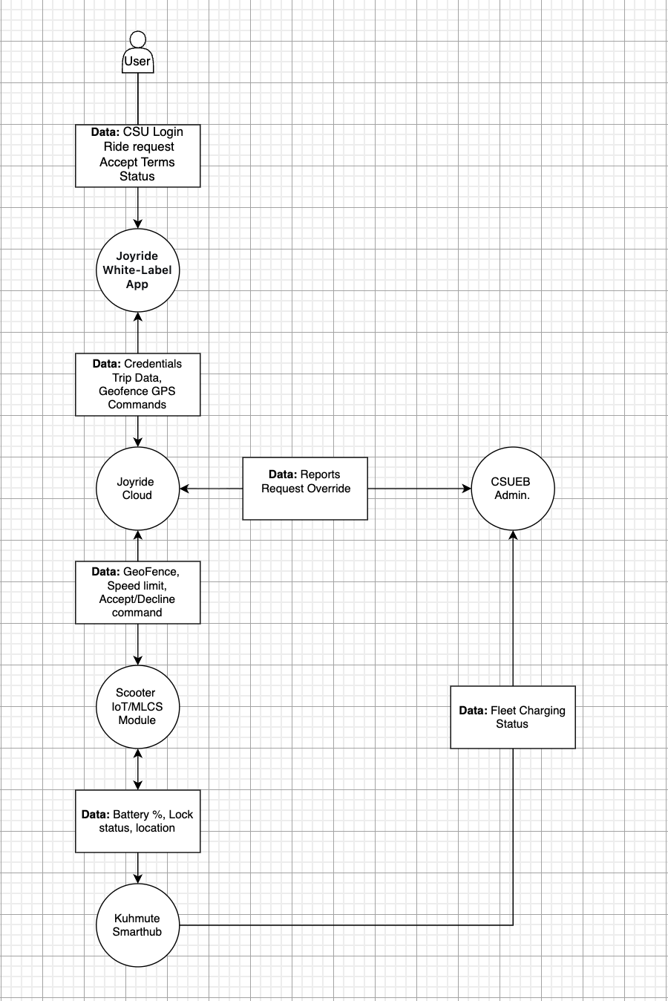
Figure 5: System Architecture

- B2. System Context:
  - All units will be speed restricted to 12mph.
  - A $6000 budget allocation will directed toward site preparation of visual lane markers and physical barrios
  - Geofencing zone is illustrated in Figure 4 and developed with GIS data.
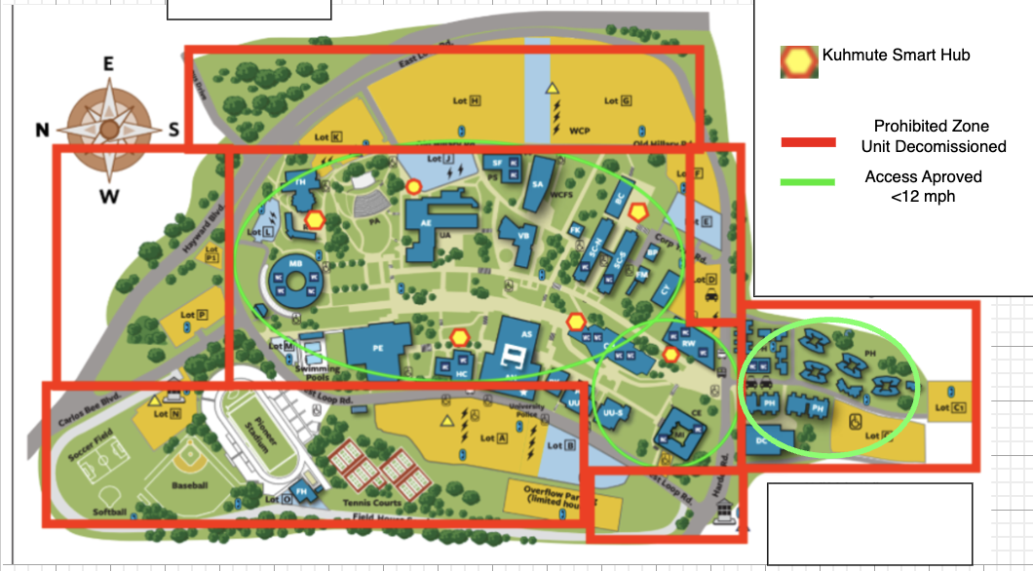
Figure 6 : Geofencing Access Zones
- B3. Functional Decomposition: (Breaking down "Move User" into "Authenticate," "Unlock," "Track," etc.).
- B4. Data Flow: (Where the user's credit card or GPS data goes).

6. Deliverables: Financials
Further Project Details and financials can be found in Excel Sheet Provided

AI FOOTNOTE:
Assistance with document structure and certain estimates was provided by DeepSeek. Final responsibility for all content rests with the author.

